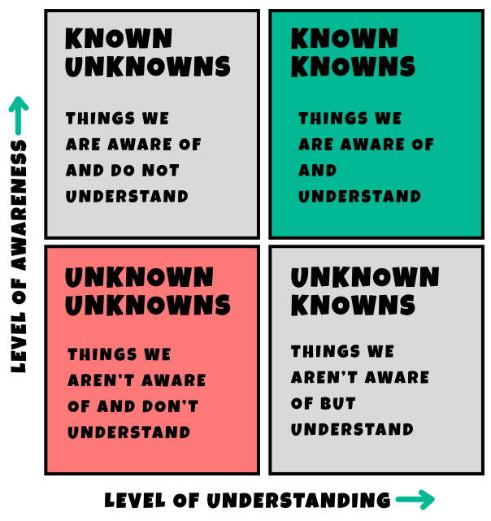
The Rumsfeld Matrix

The Rumsfeld Matrix is a decision-making framework that categorizes knowledge into four distinct quadrants. It was popularized by Donald Rumsfeld during a 2002 press briefing regarding the Iraq War. The matrix helps individuals and organizations manage uncertainty and improve decision-making.

The Four Quadrants

Quadrant Description
1. Known Unknowns Things we are aware of and don’t understand.
2. Known Knowns Things we are aware of and understand.
3. Unknown Unknowns Things we aren’t aware of and don’t understand.
4. Unknown Knowns Things we aren’t aware of but we understand.

Applications of the Matrix

1. Manage Uncertainty
The matrix breaks down complex uncertainties into smaller, manageable parts. It helps to identify assumptions that
need validation.

2. Improve Decision Making
The matrix prioritizes significant sources of uncertainty. It
encourages systematic elimination of uncertainties to make informed decisions.

3. Promote Collaboration
The matrix promotes open communication among team members. It encourages the sharing of insights and challenging assumptions.

How to use the Matrix

1. Define the context: Clarify objectives, constraints, and stakeholders.
2. Create the matrix: Draw the table with the four labels
3. Complete the matrix: List items in each quadrant based on your knowledge and understanding.
4. Identify the gaps in your knowledge and identify the people who have the missing information.
5. Try to fill the gaps in the matrix.
6. Prioritize: Focus on “known unknowns” and “unknown knowns” (the grey quadrants
above) to help to improve your decision-making.

Conclusion
The Rumsfeld Matrix is a useful tool for navigating uncertainty in various fields, including politics, business, project management and strategic planning.

